# **Introduction**

Welcome to "Epic Adventures of Mr. Peanut"! In this game, you get to be Mr. Peanut. Your job is to go on cool adventures, find solutions to puzzles, and see many exciting places. You have some special buttons to use that make playing easier and more fun. Enjoy being Mr. Peanut and have a great adventure!

# **Game Description**

Mr. Peanut’s adventures take you on a magical journey through a mysterious and magical world. It’s full of fun, humor, and surprises! You’ll be part of his big adventure, and as you go, you’ll face off against powerful enemies and uncover hidden secrets. Mr. Peanut is not only brave, but he’s also smart and has a unique sense of humor that shines through every situation. The game has special buttons to help you play better, like a healing button, a pause button, and even one to quit the game. It's easy to play and fun! If you’re looking for a fun, quirky, and engaging game that’s packed with character and heart, “Epic Adventures” is the perfect choice!

# **User Stories – Explanation of Features**

This game is designed to keep you engaged with its variety of interactive features and dynamic gameplay, inspired by the following user stories:

1. **Healing Potion Feature**: Enhance Mr. Peanut's health during critical moments with the healing potion, a tactical feature demanding careful point management.
2. **Play/Pause and Quit Options**: Gain control over your play experience with the ability to pause and quit the game easily, adding convenience and flexibility to your gaming session.
3. **Clean and Dynamic Gameplay**: Experience the satisfaction of a clean battlefield with immediate removal of defeated villains, coupled with vibrant graphical celebrations, making each victory more rewarding.

1. **In-Game FAQ Section**: Access a comprehensive FAQ section in the main menu, offering detailed answers to common questions about gameplay, making your adventure smoother and more enjoyable.
2. **Engaging Main Menu**: Dive into a user-friendly and visually appealing main menu, which serves as your gateway to various game settings and other exciting features.
3. **Flee Ability**: Use the strategic "Flee" ability for Mr. Peanut when facing tougher opponents, adding a layer of smart tactical play to your overall strategy.
4. **Restart Feature**: The option to restart the game whenever you want allows you to experiment with different strategies and enjoy uninterrupted gameplay.
5. **Quit Feature**: The option to quit the game whenever you want allows you to end the game.

Balancing action-packed sequences with strategic gameplay and user-friendly features, each aspect of the game, from the health mechanics to the interactive main menu, is thoughtfully integrated to enhance your playing experience.

User Stories

* Restart Button
* Flee Ability

**NANDINI**

# **User Story 1 – As a user, I would like to see a "Flee" ability to the character "Mr. Peanut", when he is in danger.**

I have been tasked with adding a new "Flee" ability to our character, Mr. Peanut, in the game. This feature enables Mr. Peanut to escape from dangerous situations, especially when he faces an opponent with higher health.

#### **Step-by-Step Implementation:**

1. **Creating the Flee Button:**
   * I have added a new button to our game's user interface, named "Flee."
   * I ensured this button is always visible but can be used only when Mr. Peanut's health is lower than his opponent’s.
2. **Gameplay Integration:**
   * I have made the "Flee" ability available at all game levels.
   * I focused on ensuring the ability could be used during combat, specifically when Mr. Peanut's health is lower than that of the opponent.
3. **Removing Restrictions:**
   * I have modified the game mechanics to facilitate a smooth exit for Mr. Peanut from combat upon activating the "Flee" command.
4. **Code Review & Check-In:**
   * I have conducted a detailed review of the new "Flee" function code.
   * I have checked the code against our established coding standards and ensured it maintains gameplay balance.

#### **Code Implementation:**

To be implemented in **‘FrmBattle.cs’** file.

C#

//Adding the Button for Flee Ability.

private Button fleeButton;

private FrmBattle()

{

InitializeComponent();

InitializeFleeButton();

player = Game.player;

}

// Adding the Flee Abitlity Button.

private void InitializeFleeButton()

{

this.fleeButton = new System.Windows.Forms.Button();

// Assuming btnAttack is your attack button, position btnFlee beside it

int spacing = 10; // Space between buttons, adjust as needed

this.fleeButton.Location = new System.Drawing.Point(

btnAttack.Location.X + btnAttack.Size.Width + spacing,

btnAttack.Location.Y

);

this.fleeButton.Size = new System.Drawing.Size(75, btnAttack.Size.Height);

// Make height same as attack button

this.fleeButton.Text = "Flee";

this.fleeButton.UseVisualStyleBackColor = true;

this.fleeButton.Click += new System.EventHandler(this.clickFleeButton);

this.Controls.Add(this.fleeButton);

}

private void clickFleeButton(object sender, EventArgs e)

{

tryingToFlee();

}

public bool tryingToFlee()

{

if (enemy.Health > player.Health)

{

MessageBox.Show("You are now fleeing from the Opponent.");

instance = null;

Close();

return true;

}

else

{

MessageBox.Show("You cant flee. You have more health points than the opponent.");

return false;

}

}

#### **Screenshots of Game**

* When Mr. Peanut’s health is higher than that of the enemy, if he wishes to flee from the enemy, he won’t be able to do it. [Please refer Image 2]

Image 1: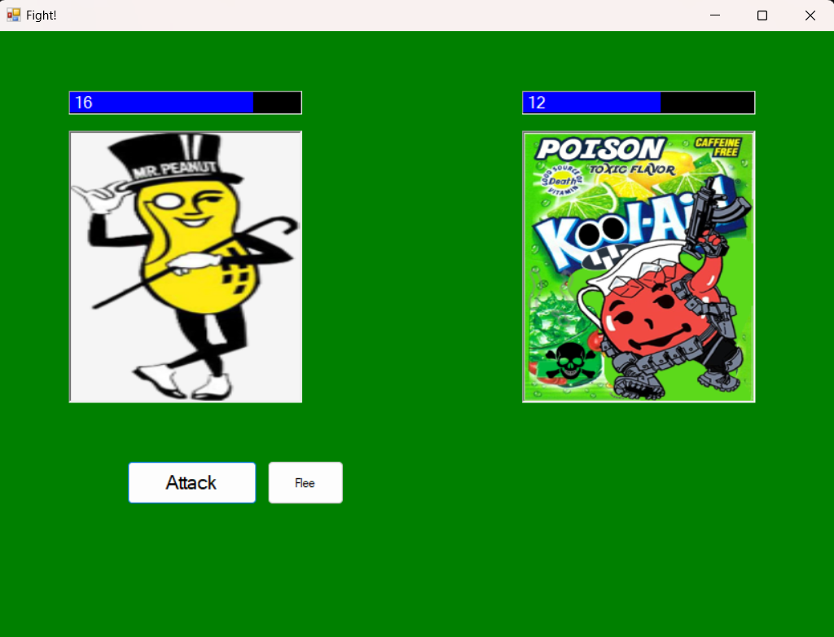

Image 2: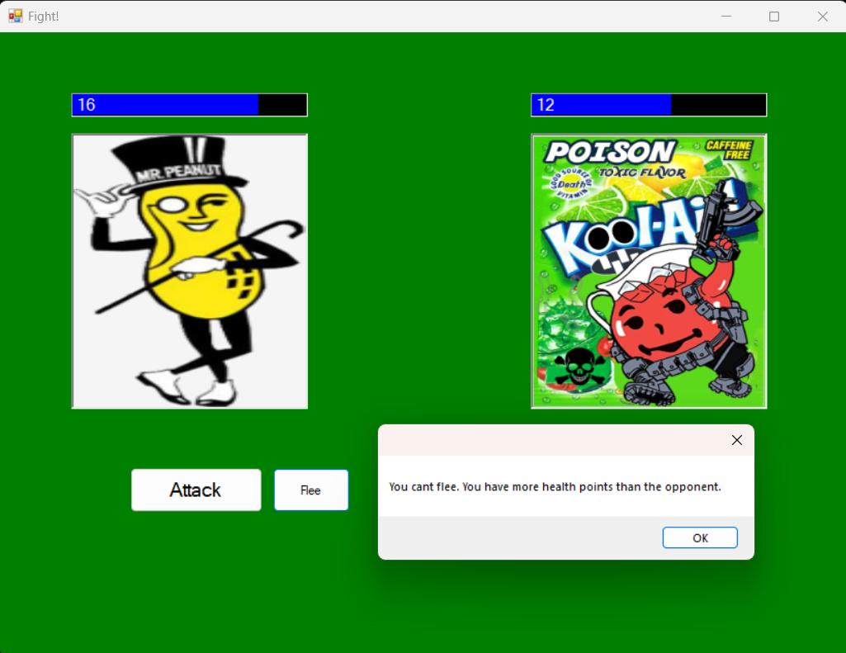

* When Mr. Peanut’s health is lower than that of the enemy, if he wishes to flee from the enemy, he can flee as the “Fight” window is closed. [Please refer Image 4]

Image 3:

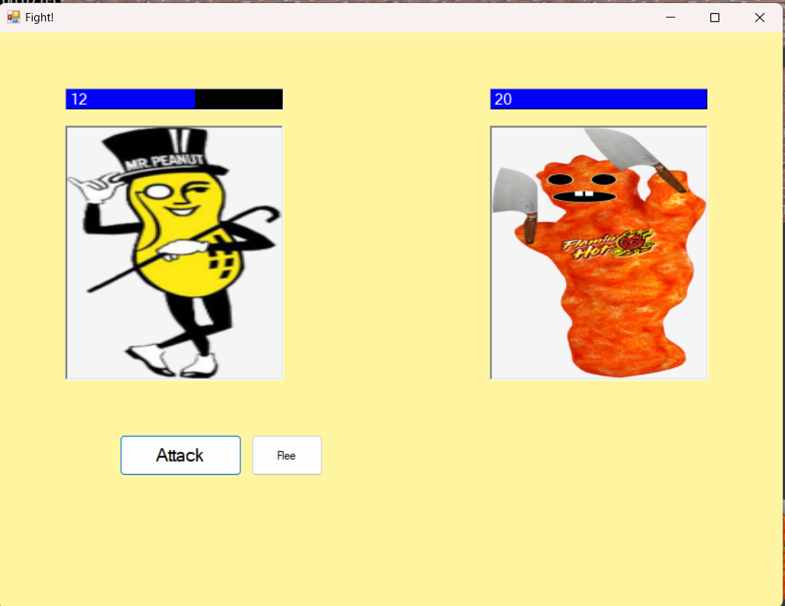

Image 4: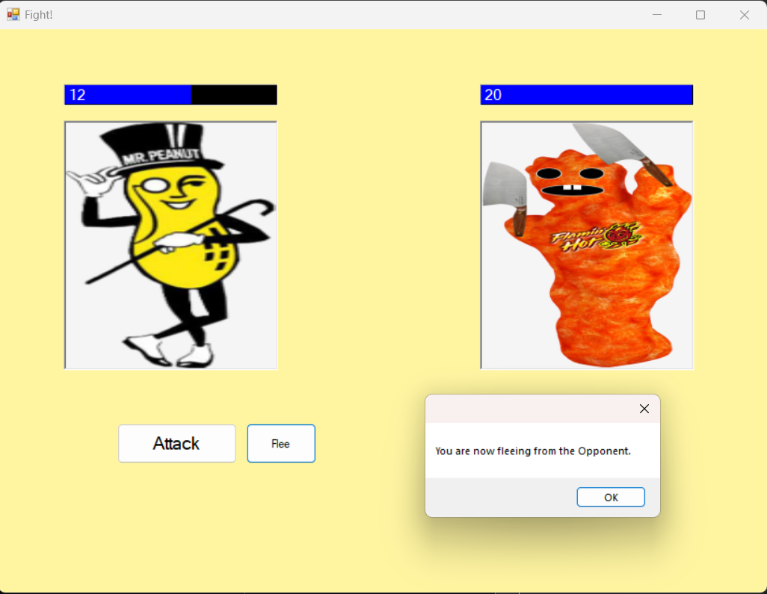

# **User Story 2 – As a user, I would like there to be a button that allows me to restart the game whenever I want.**

I have integrated a "Restart" button into our game, following the user's request for a simple and direct way to restart the game at any point. This addition enhances the user experience by allowing players more control over their game session.

#### **Step-by-Step Implementation:**

1. **Creating the Restart Button:**
   * I have designed and positioned a new "Restart" button within the game's menu or other accessible options.
   * I have made sure the button is clearly labelled and easily identifiable for the users.
2. **Functionality Implementation:**
   * I have added functionality so that whenever the user presses the "Restart" button, the game immediately resets taking the user to the main menu.
   * I ensured that the button is always available to the player during the gameplay, offering instant access to restart the game.
3. **Code Review & Check-In:**
   * I have thoroughly reviewed and tested the changes related to the "Restart" button to ensure they meet our coding standards.
   * I focused on ensuring that the button's integration doesn’t introduce any bugs and works smoothly within the game's existing architecture.

#### **Code Implementation:**

// Code to Initialize the Restart Button in the FrmLevel Code.

private void InitializeRestartButton()

{

restartButton = new Button();

restartButton.Text = "Restart";

restartButton.Click += RestartButtonClick;

// Code to remove the focus from the restart button.

restartButton.TabStop = false;

// Setting the size and position of the restart button right beside the Quit Button.

restartButton.Size = new Size(60, 30);

restartButton.Location = new Point(quitButton.Location.X - restartButton.Width - 10, quitButton.Location.Y);

// Code to make sure that the Restart Button stays right beside the Quit button even if the application is resized.

this.Resize += (sender, e) => {

restartButton.Location = new Point(quitButton.Location.X - restartButton.Width - 10, restartButton.Location.Y);

};

this.Controls.Add(restartButton);

}

// The function for performing the restart of the game.

private void RestartButtonClick(object sender, EventArgs e)

{

Application.Restart();

Environment.Exit(0);

}

#### **Screenshots of Game**

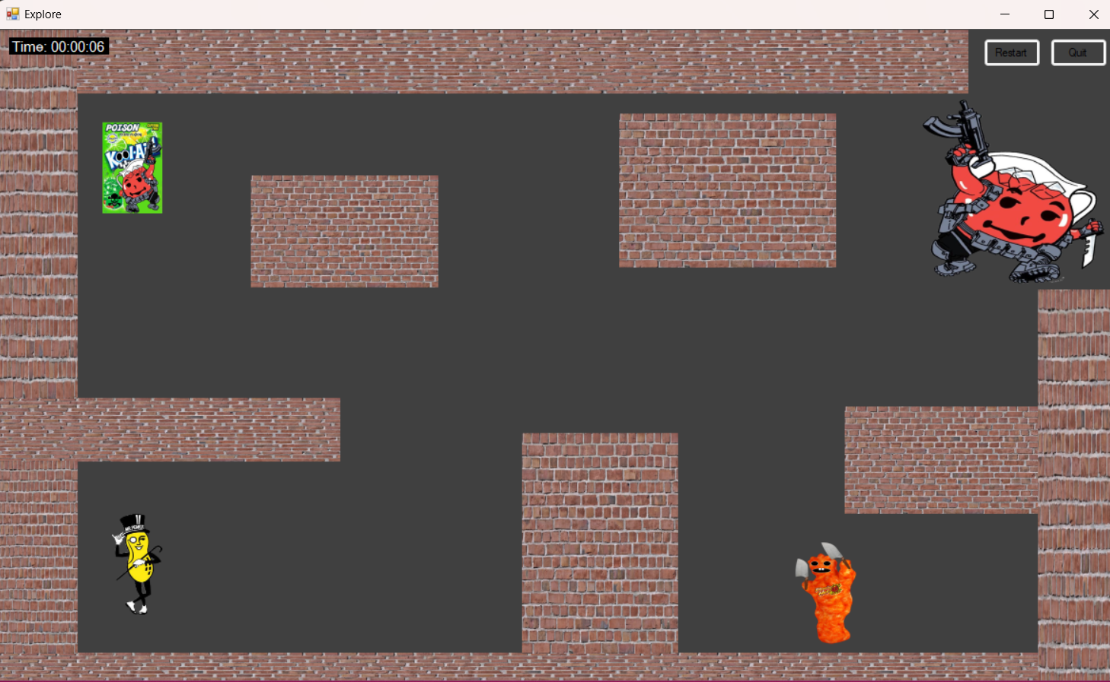

User Stories

* Main Menu
* User FAQ’s

**VAISHNAVI**

# **User Story 3 – Add main menu to the game.**

I have developed and integrated a main menu screen into our game. This menu is the first interface the player encounters upon launching the game, providing access to various game features such as starting a new game, quitting the game and other content.

#### **Step-by-Step Implementation:**

1. **Main Menu Accessibility:**
   * I have configured the game to launch directly into the main menu screen. This is the initial interface players see when they start the game.
   * The main menu serves as a central hub for navigating to different parts of the game.
2. **Incorporating Key Features:**
   * I have included options within the main menu to access buttons for “New Game”, “Quit” and “User FAQ’s”.
   * Each option is designed to be user-friendly and intuitive, ensuring that players can easily find and adjust their desired settings or explore additional features.
3. **Designing the Main Menu:**
   * I have crafted the layout of the main menu and positioned relevant buttons, ensuring the interface is functional.
4. **Code Review & Check-In:**
   * I have rigorously reviewed the code underpinning the main menu, checking for adherence to our established coding standards.
   * My focus has been on ensuring the code's efficiency, readability, and integration with the existing game architecture.

#### **Code Implementation:**

// Button for the Main Menu.

private Panel mainMenuPanel;

// Buuton for New Game option in the main menu to start the game.

private Button newGameButton;

// Start of the game code.

public FrmLevel()

{

InitializeComponent();

//InitializeTheQuitButton();

//InitializeRestartButton();

this.KeyPreview = true;

// Initialize the game in 'menu state'

SetupMainMenu();

InitializeGameComponents(false); // Add this method

}

// Code to Initialize the Restart Button in the FrmLevel Code.

private void InitializeGameComponents(bool visible)

{

foreach (Control control in this.Controls)

{

if (control != mainMenuPanel)

{

control.Visible = visible;

}

}

}

private void SetupMainMenu()

{

// Spacing and sizing

int buttonWidth = 180;

int buttonHeight = 30;

int spacing = 10;

int headingHeight = 20; // Height for the heading label

int extraPadding = 50; // Extra space for aesthetics or other controls

int numButtons = 4; // Total number of buttons

// Dynamic height calculation

int panelHeight = (buttonHeight + spacing) * numButtons + headingHeight + spacing + extraPadding;

mainMenuPanel = new Panel()

{

Size = new Size(200, panelHeight),

Location = new Point((this.ClientSize.Width - 200) / 2, (this.ClientSize.Height - panelHeight) / 2),

BackColor = Color.Black

};

this.Controls.Add(mainMenuPanel);

// Label for Main Menu

Label lblMainMenu = new Label()

{

Text = "Main Menu",

ForeColor = Color.White,

BackColor = Color.Transparent,

Size = new Size(180, headingHeight),

Location = new Point(10, 10), // Position at the top

TextAlign = ContentAlignment.MiddleCenter

};

mainMenuPanel.Controls.Add(lblMainMenu);

// Calculate the starting Y position for the buttons

int startY = lblMainMenu.Bottom + spacing;

// New Game Button

newGameButton = new Button()

{

Text = "New Game",

Size = new Size(buttonWidth, buttonHeight),

Location = new Point(10, startY),

ForeColor = Color.White,

BackColor = Color.Black

};

newGameButton.Click += NewGameButton_Click;

mainMenuPanel.Controls.Add(newGameButton);

// Quit Button

startY += buttonHeight + spacing; // Update startY for next button

quitButton = new Button()

{

Text = "Quit",

Size = new Size(buttonWidth, buttonHeight),

Location = new Point(10, startY),

ForeColor = Color.White,

BackColor = Color.Black

};

quitButton.Click += (sender, e) => Application.Exit();

mainMenuPanel.Controls.Add(quitButton);

// User FAQ's Button

startY += buttonHeight + spacing; // Update startY for next button

buttonForUserFAQ = new Button()

{

Text = "User FAQ's",

Size = new Size(buttonWidth, buttonHeight),

Location = new Point(10, startY),

ForeColor = Color.White,

BackColor = Color.Black

};

buttonForUserFAQ.Click += (sender, e) => showTheFAQForm();

mainMenuPanel.Controls.Add(buttonForUserFAQ);

}

private void NewGameButton_Click(object sender, EventArgs e)

{

StartNewGame();

}

private void StartNewGame()

{

mainMenuPanel.Visible = false;

InitializeGameComponents(true); // Show the game components

InitializeRestartButton();

InitializeButtonForPlayPause();

//restartButton.Visible = true;

}

#### **Screenshots of the Game:**

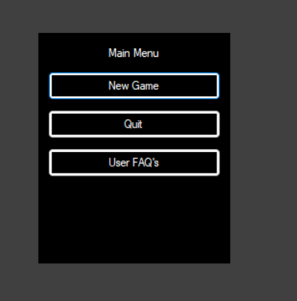

When the button for New Game is clicked, we enter the game.

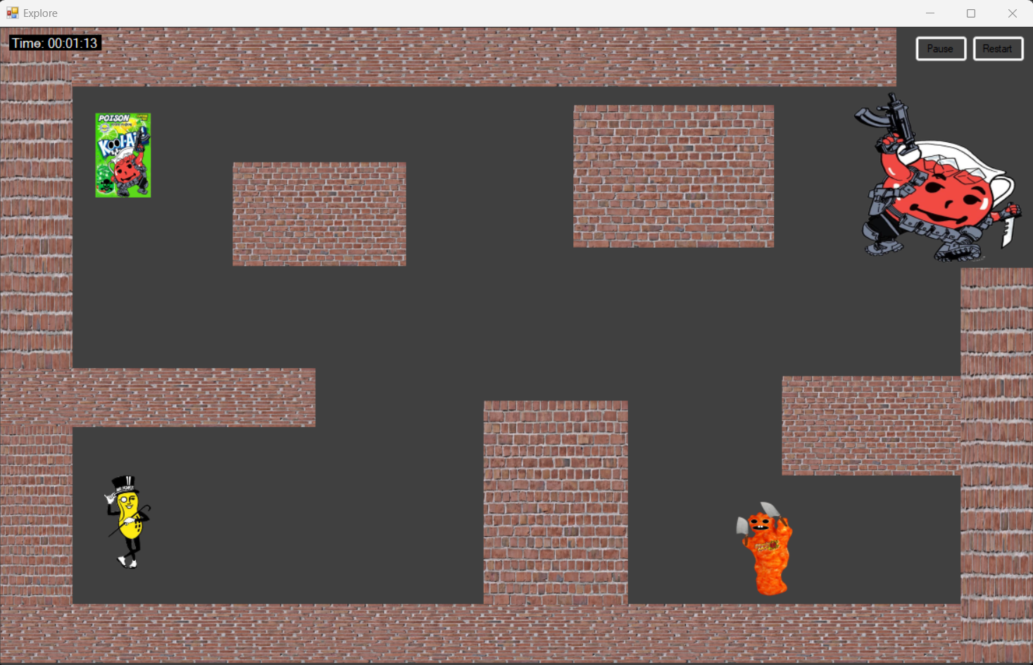

When we click the button for Quit, we exit the game altogether.

When we click the button for User FAQ, we get a Dialog box for user faq’s.

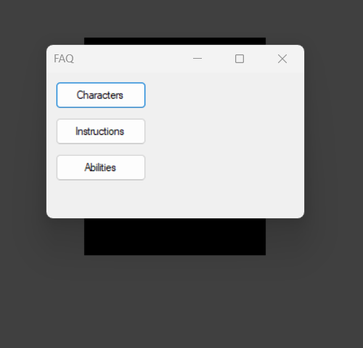

# **User Story 4 – Add the User FAQ Button for the Frequently Asked Questions by the Users.**

I have introduced an FAQ (Frequently Asked Questions) section to our game's main menu. This section aims to address common queries from players. The content is structured in a detailed Q&A format for clarity and ease of understanding.

#### **Steps for Implementation:**

1. **FAQ Form Creation:**
   * I have created a new form within the main menu dedicated to FAQs. This form is easily accessible and user-friendly, ensuring players can find answers to their queries effortlessly.
2. **Content Development:**
   * I have compiled a list of potential questions that players might have.
   * For each question, I have provided detailed answers, explaining each topic thoroughly to enhance player understanding and satisfaction.
3. **Formatting and Design:**
   * The FAQ content is organized in a clear Q&A format. Each question stands out for easy reading, followed by concise yet comprehensive answers.

#### **Code Implementation:**

// Button for the UserFAQ's in the Main Menu.

private Button buttonForUserFAQ;

// This part of the code is present in the Main Menu Panel Code.

// User FAQ's Button

startY += buttonHeight + spacing; // Update startY for next button

buttonForUserFAQ = new Button()

{

Text = "User FAQ's",

Size = new Size(buttonWidth, buttonHeight),

Location = new Point(10, startY),

ForeColor = Color.White,

BackColor = Color.Black

};

buttonForUserFAQ.Click += (sender, e) => showTheFAQForm();

mainMenuPanel.Controls.Add(buttonForUserFAQ);

private void showTheFAQForm()

{

Form faqForm = new Form()

{

Size = new Size(300, 200),

FormBorderStyle = FormBorderStyle.FixedDialog,

StartPosition = FormStartPosition.CenterParent,

Text = "FAQ"

};

// Button for Characters FAQ

Button btnCharacters = new Button()

{

Text = "Characters",

Size = new Size(100, 30),

Location = new Point(10, 10)

};

btnCharacters.Click += (sender, e) => ShowFaqDetails("Characters");

faqForm.Controls.Add(btnCharacters);

// Button for Instructions FAQ

Button btnInstructions = new Button()

{

Text = "Instructions",

Size = new Size(100, 30),

Location = new Point(10, 50)

};

btnInstructions.Click += (sender, e) => ShowFaqDetails("Instructions");

faqForm.Controls.Add(btnInstructions);

// Button for Abilities FAQ

Button btnAbilities = new Button()

{

Text = "Abilities",

Size = new Size(100, 30),

Location = new Point(10, 90)

};

btnAbilities.Click += (sender, e) => ShowFaqDetails("Abilities");

faqForm.Controls.Add(btnAbilities);

faqForm.ShowDialog();

}

private void ShowFaqDetails(string faqType)

{

string contentForFAQ = "";

switch (faqType)

{

case "Characters":

contentForFAQ = "Q: Are there any other characters that are available so I can select it to play in the game?\n" +

"A: Sorry. Right now we only have one character. We will be getting more characters in future.\n\n" +

"Q: Is KoolAid Man the opponent I need to fight last?\n" +

"A: Yes, He is the boss so you need to fight him at last.";

break;

case "Instructions":

contentForFAQ = "Q: WHat should i do to move the player?\n" +

"A: You can just press the arrow keys in the keyboard for the movement of the player..\n\n" +

"Q: Can the Enemies move?\n" +

"A: No the enemies cannot move.";

break;

case "Abilities":

contentForFAQ = "Q: What is the Flee Ability?\n" +

"A: The flee ability allows you to flee the battle with the enemy when you have less health points.\n\n" +

"Q: What is the Heal Ability?\n" +

"A: When you have less health points than the enemy, yopu can click on the Heal button to make your health points as full..";

break;

default:

contentForFAQ = "No FAQ available for this category.";

break;

}

MessageBox.Show(contentForFAQ, $"{faqType} FAQs");

}

#### **Screenshots of Game:**

Clcik the User FAQ button in the Main Menu for the Dialog Box with Buttons for Various Frequently Asked Questions.



Click on Characters for Q&A on the Characters of the game.

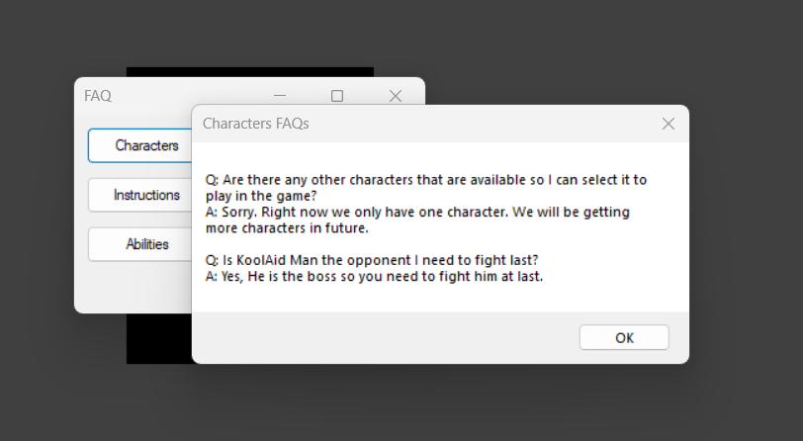

Click on Instructions Button for the game instructions.

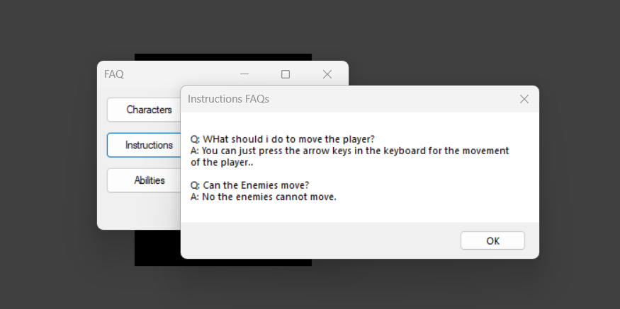

Click on the Abilities button to learn about the various abilities of Mr.Peanut in the battle.

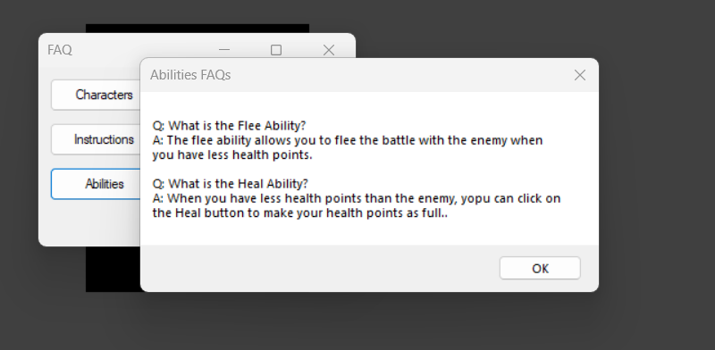

User Stories

* Healing Button
* Play/Pause

**SAHANA**

# **User Story 5 - As a user, I would like to see an increase in the health when I click the healing potion button.**

According to the feature I’m here to access the healing potion button, whenever Mr. Peanut attack the enemy the health decreases, to increase the health need to tap on the heal button and the function allows to upgrade their health.

#### **Step-by-Step Implementation:**

**Creating healing button:**

Adding healing button to the game and named as ‘HEAL’.

It is visible when enemy attacks Peanut.

**Design and prototype:**

I designed the button in the game, can be flexible on using functionality game play.

Focusing on the button and implementing the heal potion according to the game.

After creating modeling the game performing actual process lead to process the game functionality.

**Code Review:**

I observed that the functionality of the button is processing as I assumed, and the code is suitable for the particular game.

I done code review based on the given code.

#### **Code Implementation:**

To be implemented in **‘FrmBattle.cs’** file.

C#

//Adding the Button to healing potion.

private void InitializeButtonForHealing()

{

this.healButton = new System.Windows.Forms.Button();

int spacing = 10;

this.healButton.Location = new System.Drawing.Point(fleeButton.Location.X + fleeButton.Size.Width + spacing, fleeButton.Location.Y);

this.healButton.Size = new System.Drawing.Size(75, fleeButton.Size.Height);

this.healButton.UseVisualStyleBackColor = true;

this.healButton.Text = "Heal";

this.healButton.Click += new System.EventHandler(this.clickHealButton);

this.Controls.Add(this.healButton);

}

private void clickHealButton(object sender, EventArgs e)

{

PlayerHealing();

UpdateHealthBars();

}

private void PlayerHealing()

{

int totalHealAmount = 20;

int healthDeficit = player.MaxHealth - player.Health; // Calculate how much health is missing to reach max

if (player.Health + totalHealAmount >= player.MaxHealth)

{

player.AlterHealth(healthDeficit); // Heal up to the maximum health

if (healthDeficit == 0)

{

MessageBox.Show("You already have full Health. You cannot increase it more.", "Health Full", MessageBoxButtons.OK, MessageBoxIcon.Information);

}

else

{

MessageBox.Show("You are healed now. You have full Health. All the best for the battle ahead of you!", "Healed", MessageBoxButtons.OK, MessageBoxIcon.Information);

}

}

else

{

player.AlterHealth(totalHealAmount); // Heal the player by the total heal amount

MessageBox.Show($"You are healed by {totalHealAmount} points.", "Healing", MessageBoxButtons.OK, MessageBoxIcon.Information);

}

}

#### **Screenshots of Game**

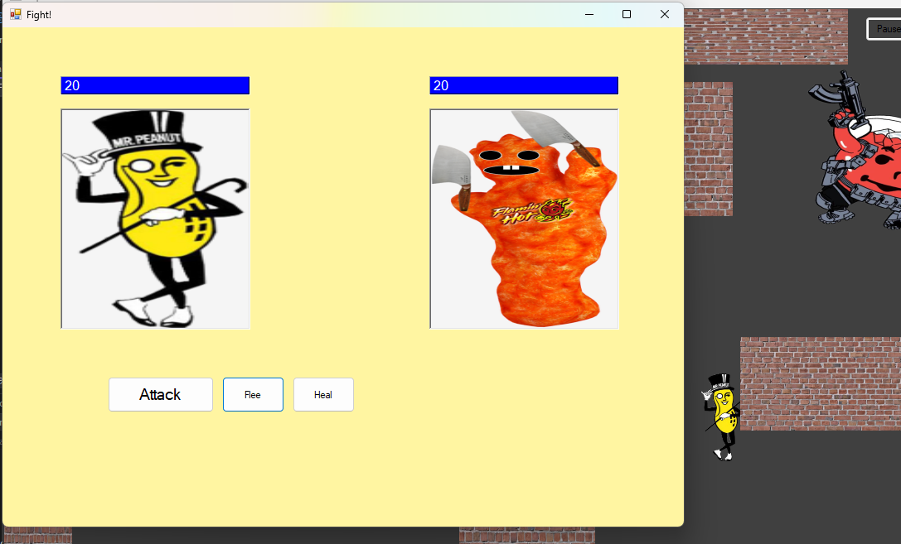

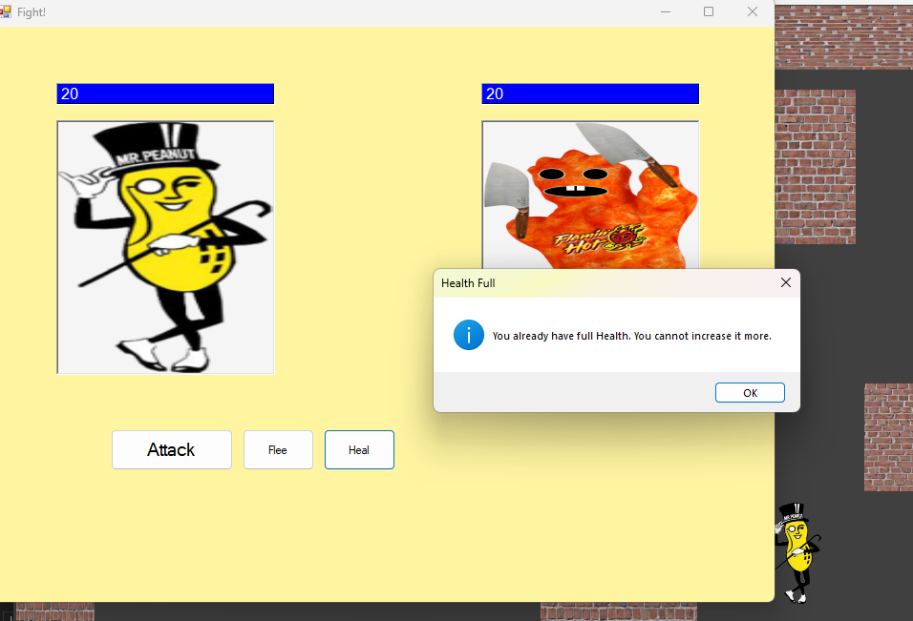

# **User Story 6 - As a user, I would like to create a button that allows players to play or pause the game.**

According to the feature, I need to create a play pause button in the game. Need of the pause button is to use whenever it is necessary, pause button use to pause the game and resume the game.

#### **Step-by-Step Implementation:**

**Creating pause button:**

Adding pause button to the game allows players to temporarily halt the game, so that they can take a break.

In most cases setting the time to pause the game, and return to the game whenever it is needed.

**Design and prototype:**

I designed the game for pause button that is need to run the game, by using this method nothing can be affected.

In practice, in most cases everything will be stopped when game is paused.

**Code review:**

The functionality of the code is to pause the game, and I created the code to process the pause play button.

#### **Code Implementation:**

To be implemented in **‘Frmlevel.cs’** file.

C#

//Adding play pause button.

// The Intialization function for adding the play/pause button for the game.

private void InitializeButtonForPlayPause()

{

buttonForPlayPause = new Button();

buttonForPlayPause.Size = new Size(60, 30);

buttonForPlayPause.Text = "Pause";

buttonForPlayPause.Location = new Point(restartButton.Location.X - buttonForPlayPause.Width - 5, restartButton.Location.Y);

buttonForPlayPause.Click += clickButtonForPlayPause;

this.Controls.Add(buttonForPlayPause);

buttonForPlayPause.BringToFront();

}

private void clickButtonForPlayPause(object sender, EventArgs e)

{

gameIsPaused = !gameIsPaused;

buttonForPlayPause.Text = gameIsPaused ? "Play" : "Pause";

if (gameIsPaused)

{

tmrPlayerMove.Stop();

tmrUpdateInGameTime.Stop();

}

else

{

tmrPlayerMove.Start();

tmrUpdateInGameTime.Start();

}

}

#### **Screenshots of Game**

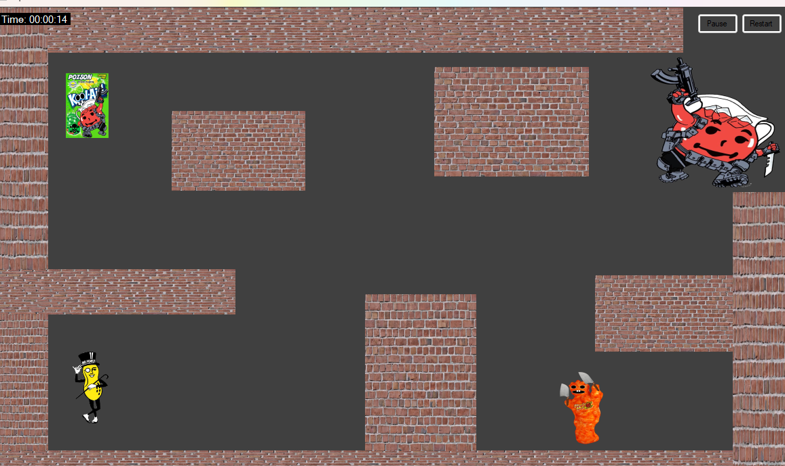

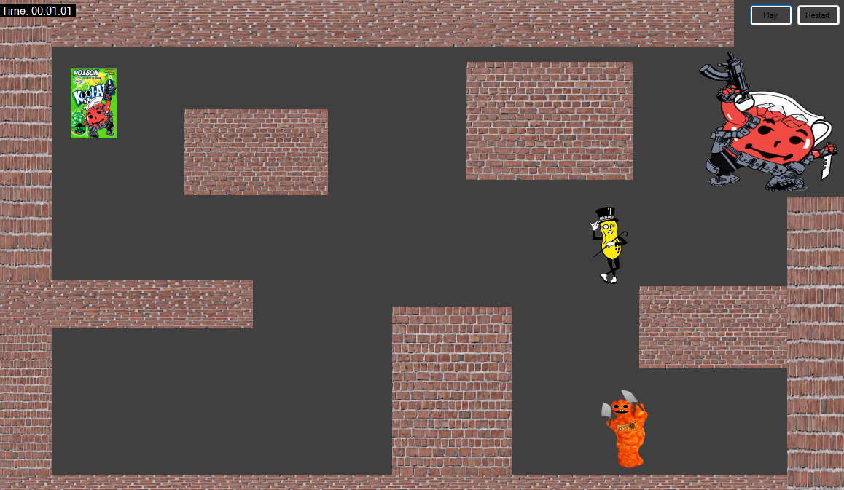

User Stories

* Clean and Dynamic Option
* Quit Feature

**MANIKANTA LANKE**

# **User Story 7 – As a user, I would like to clean up all the dead bodies of enemies.**

I have been tasked with clean and dynamic gameplay with our enemies whoever is killed.

Experience the satisfaction of a clean battlefield with the immediate removal of defeated villains, coupled with vibrant graphical celebrations, making each victory more rewarding.

#### **Step-by-Step Implementation:**

**Modify the Enemy class**

I have added a method to my ‘Enemy’ class that handles the removal of a defeated enemy.

**Update the Fight Method in Frmlevel**

**I have modified the ‘Fight’ method in my ‘Frmlevel’ class to class to call the ‘Defeat’ method of the defeated enemy and then remove it from the game.**

**Create the RemoveEnemy Method**

**As previously I have used ‘RemoveEnemy’ in my method my ‘Frmlevel’ class to remove the defeated enemy from the form.**

**Use the Updated Fight Method**

**Now in my game code, when an enemy is defeated, I can call the ‘Fight’ method with the defeated enemy to remove it from the game.**

#### **Code Implementation:**

**To implement a Clean and Dynamic Gameplay file.**

**C#**

// adding code to implement a clean and dynamic gameplay.

private void Fight(Enemy enemy) {

player.ResetMoveSpeed();

player.MoveBack();

frmBattle = FrmBattle.GetInstance(enemy);

frmBattle.Show();

if (enemy == bossKoolaid) {

frmBattle.SetupForBossBattle();

}

RemoveEnemy(enemy);

}

private void RemoveEnemy(Enemy enemy)

{

if (enemy == enemyPoisonPacket)

{

picEnemyPoisonPacket.Visible = false;

}

else if (enemy == bossKoolaid && enemy.Health == 0)

{

picBossKoolAid.Visible = false;

}

else if (enemy == enemyCheeto)

{

picEnemyCheeto.Visible = false;

}

}

#### **Screenshots of Game:**

* When Mr. Peanut has a battle with the enemy, the enemy will disappear.

Image 1:

Initially enemy was appearing before battle

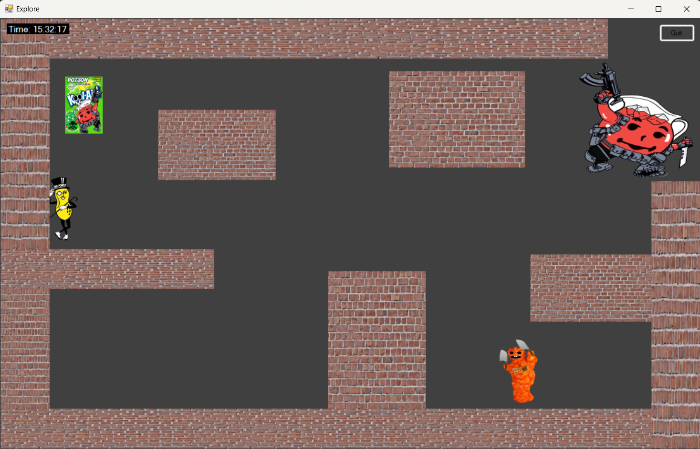

Image 2:

Enemy 1 disappeared after battle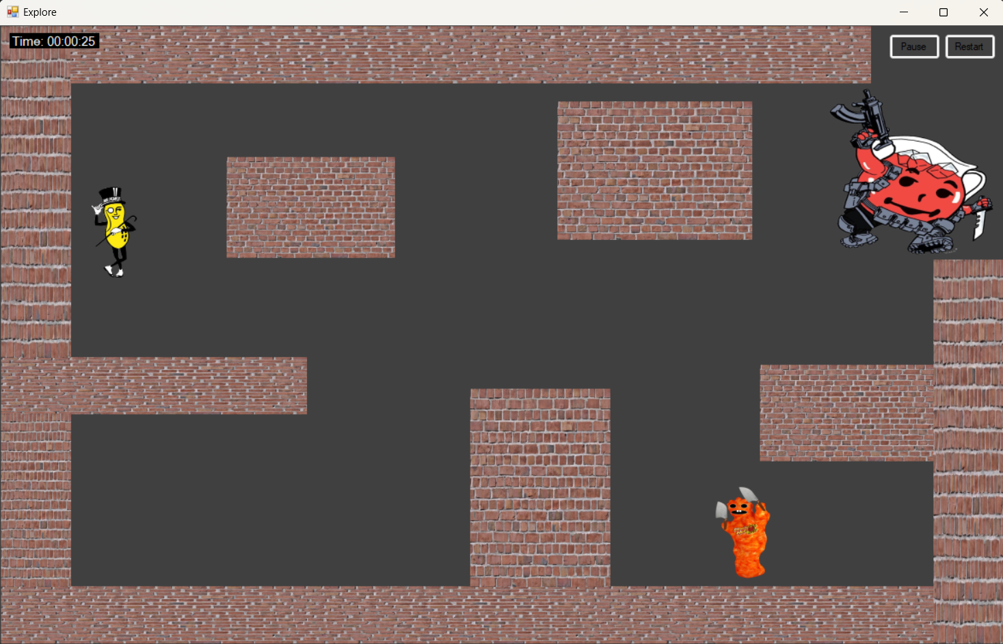

Image 2:

Enemy 2 gets disappeared after battle

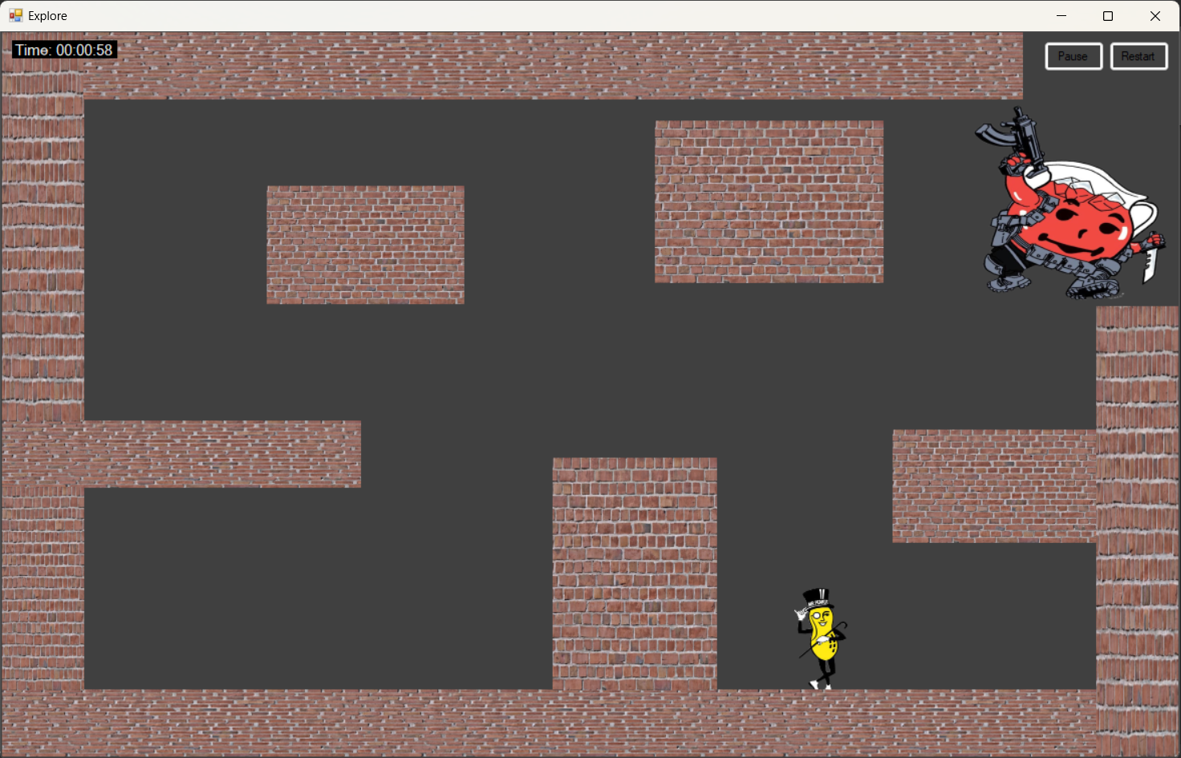

# **User Story 8 – As a user, I would like to have a button that allows me to quit the game whenever I want**

The option to quit the game whenever you want allows you to end the game.

#### **Step-by-Step Implementation:**

1. **Adding a Quit Button**

* In my ‘frmlevel’ form, I would like to add a “Quit” button.

1. **Set Button Properties.**

* With the “Quit” button added to my form, I can set its properties.

1. **Implement the quit Functionality.**

* Next, I need to add functionality to the “Quit” button.

1. **Attach the Event handler and test the quit button**

* Ensuring that the btnQuit_click method is called when the Quit button is clicked I have attached the event handler to the button.
* Now, When I run the game, I should see the ‘Quit’ button on my form. Clicking it will trigger the “btnQuit_click” method, which calls ‘Application.Exit() to quit whenever I want

#### **Code Implementation:**

// Button for Quitting the Game.

private Button quitButton;

// This part of the code is added in the Main Menu Panel.

// Quit Button

startY += buttonHeight + spacing; // Update startY for next button

quitButton = new Button()

{

Text = "Quit",

Size = new Size(buttonWidth, buttonHeight),

Location = new Point(10, startY),

ForeColor = Color.White,

BackColor = Color.Black

};

quitButton.Click += (sender, e) => Application.Exit();

mainMenuPanel.Controls.Add(quitButton);

#### **Screenshots of Game:**

